**How to order TSC business cards and stationary through ODP punchout**

1. Log in to Workday
2. Click on the REQUISITIONS app
3. Select CONNECT TO SUPPLIER WEBSITE
4. Connect to the ODP Business Solutions website

1. Click on the PRODUCTS menu in the top left of the screen

1. Select BRAND IDENTITY

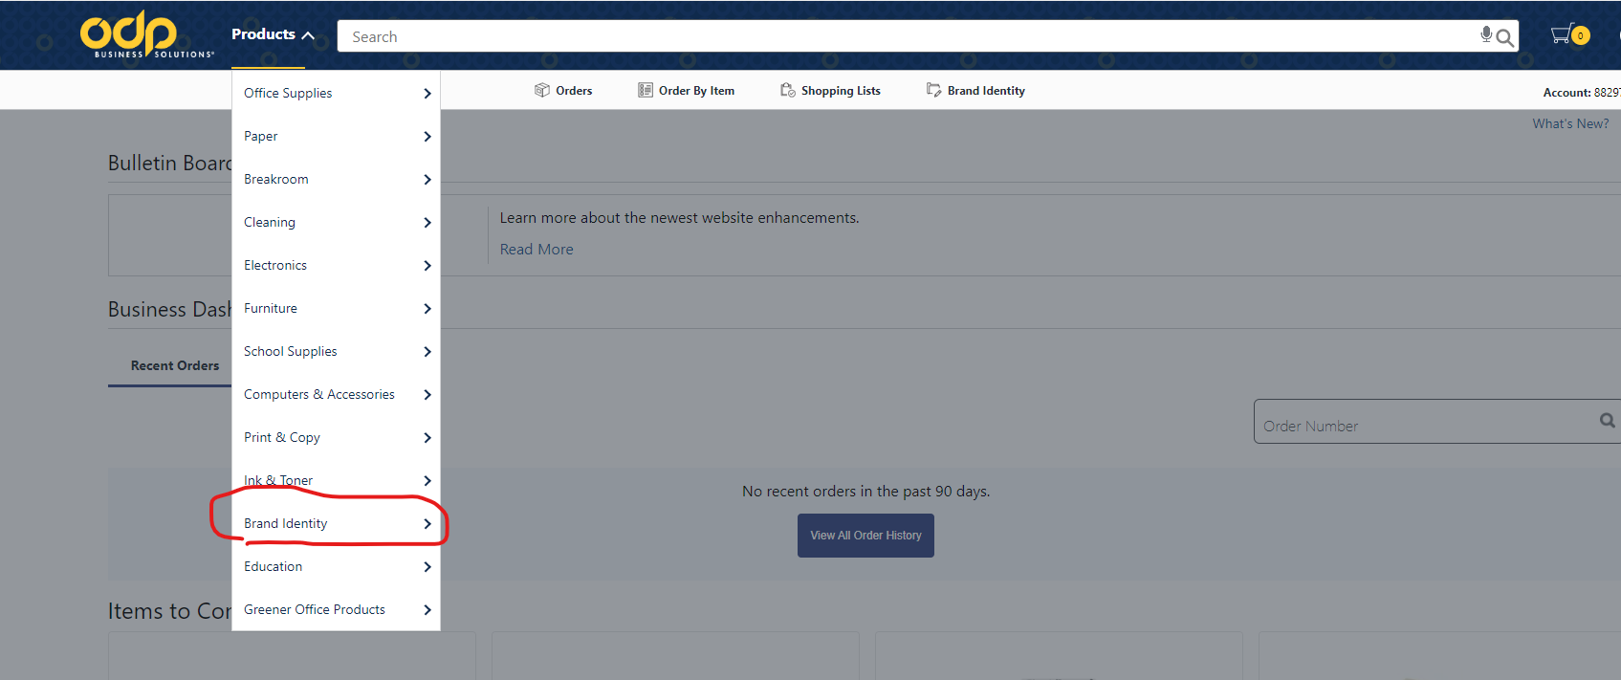

1. Select the template and click CREATE (**only applies to** **business cards)**

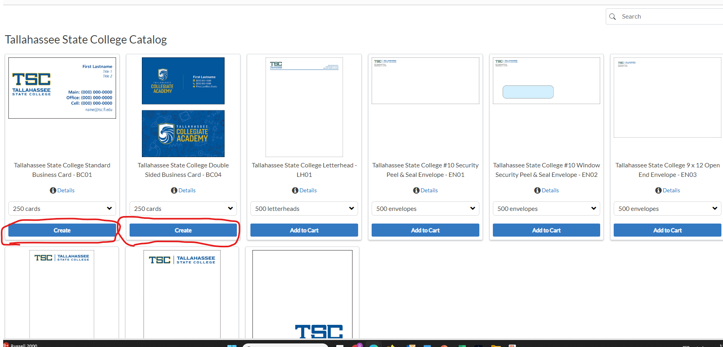

1. Enter your information, check your proof, and click NEXT

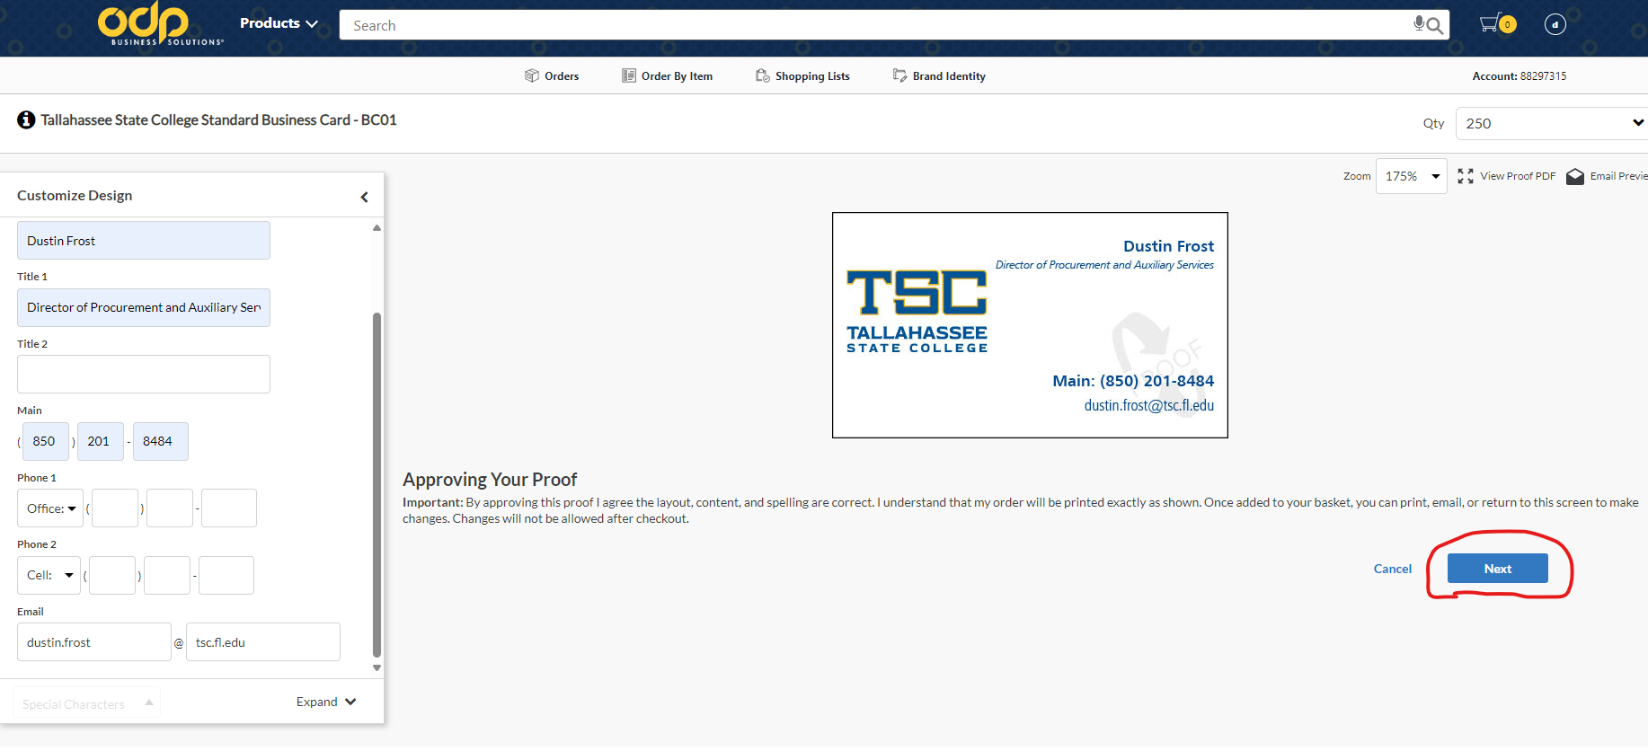

1. Check your cart and click NEXT

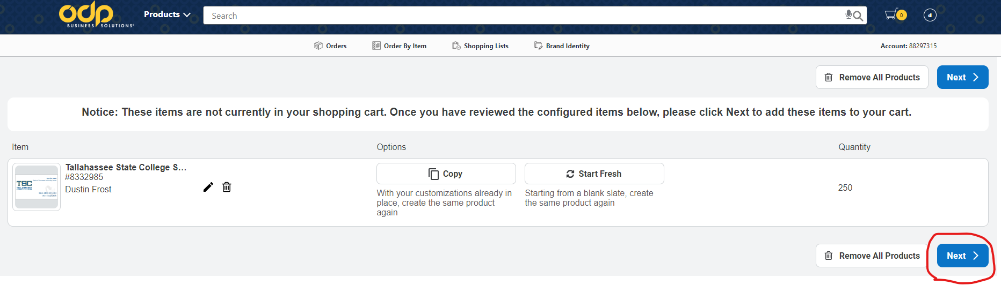

1. Click CHECKOUT and follow the prompts

1. Will now take you back to Workday to complete the Requisition process